| 数量 | 成本 | 售价 | 重量 |
| --- | --- | --- | --- |
| 0～9 | ￥260 | $49.90 | 102g |
| 10+ | ￥245 | $47.50 |

WS2812B Digital 5050 RGB LED Flexible Strip - 4M Black PCB 60LEDs/M

Description

This is a roll of controllable RGB LED trip. It is of 4 meter, each meter has 60 LEDs. The type of LED is WS2812B, which is individually addressable and has 256 brightness display and 16777216 color variance. The body of this LED strip is flexible PCB, with only 1mm thinness. The reverse side of LED strip is pre-stuck by 3M tape, you can tear the protective film and glue the LED strip on the wall or desktop. Besides, the LED trip is cuttable, if 5m is too long for you, you can directly cut it into other length, 1m, 2m, even the single LED.

The LED strips use 5V power and only one signal input port. By the simple circuit connection, you are able to control it. As to the software driver, there is an open sources library Neopixel Library that written by Adafruit team, it supports running on Arduino platform. What you may need to note, the maximum power of the WS2812B is 0.24W(all LEDs on full brightness), if lots of LED you are using, you may need a large power 5V supply.

Wiring Diagram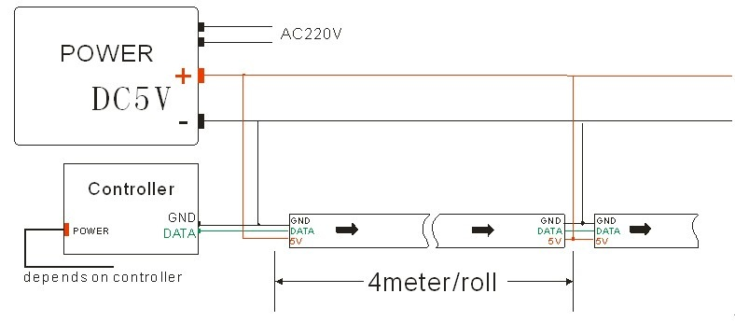

Specifications

* Package: 4m a roll, 60 LEDs per meter
* Input Voltage: 3.5V ~ 5.3V (do not exceed 6VDC, no polarity protection)
* Max. Power: 0.3W per LED
* LED Wavelengths: R-630nm, G-530nm, B-475nm
* Signal: NZR, 800kbps WS2811 chip build in
* Data Output: Build in signal reshaping to DOUT for cascading to the next chip
* Precision: 8 bits/256 shades per color (24 bits per chip, 16M colors total)
* View Angle: 120 degree
* Life Span: no less than 50,000hrs
* Connector: 2-pin JST SM

Outside Dimensions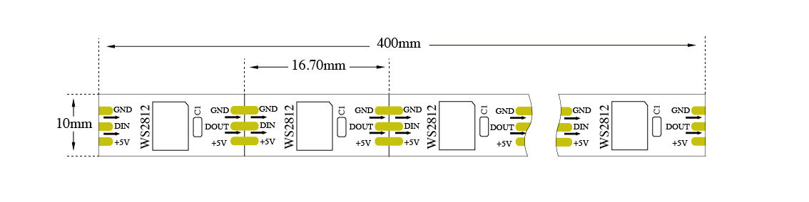

Documentations

* WS2812B Data sheet(上传文档到服务器，并添加链接) - Pay attention carefully the “Reflow Considerations”
* [OctoWS2811 LED Library](http://www.pjrc.com/teensy/td_libs_OctoWS2811.html) - Driving hundreds to thousands of LEDs
* [Adafruit NeoPixel Library](https://github.com/adafruit/Adafruit_NeoPixel) - Based on Arduino platform
* [Light weight library](https://github.com/cpldcpu/light_ws2812) - For 8-Bit AVR micro controllers